AUDIO SMARTWATCH PICTURE DESCRIPTION AS AN ALTERNATIVE IN RECOGNIZING IMAGES FOR THE VISUALLY IMPAIRED
Gusua Reza¹, Nadia Srimardayeti², Elsa Cipto Riani³, Usin⁴, Arisul Mahdi, M.Pd⁵
^{1,2,5} Faculty Of Science Education,Univeristas Negeri Padang, INDONESIA
^{3,4}Faculty of Engineering,Univeristas Negeri Padang, INDONESIA
E-mail: : rezagusua@gmail.com

ABSTRACT
Audio Smartwatch Picture Description is a tool that was designed by itself by utilizing a camera sensor as an image detector and a microphone working to add sound output which is combined with an image description program that has been created on Arduino so that it becomes a unified tool that has the function of describing images into sound output. The purpose of making the tool is to design an image description tool in the form of a smart watch that can be used by blind children in recognizing and identifying images so as to help blind people in obtaining information easily and independently. The making of the tool started by conducting observations and interviews related to learning media and fulfilling accessibility at PSBN Tuah Sakato Padang City and SMK 7 Padang City. From the results of observations, planning for the manufacture of tools and conducting a literature study on the components needed, after planning followed by making the design of tools and components. The design of the tools and components has been completed with a survey and the purchase of the required tools and components, after all the requirements have been met for the manufacture of the tool by involving a third party in the manufacturing program. The tools that have been designed for testing are limited to blind experts and techniques for testing tools and testing on the blind. From the results of trials on experts and the blind, the results obtained for the tool to be lighter so that it can be used for training by the blind. The test results are used as evaluation material in improving the tool. Furthermore, the publication of the tool through scientific articles that have been submitted in the Special Needs Education Journal accredited by SINTA 4.

Keywords: Picture Description, Audio, Smartwatch, Recognition, Visual Impairments

- INTRODUCTION
Data for peoples with disabilities in 2015 based on data from the Central Bureau of Statistics summarized through the Population Census, Inter-Census Population Survey (SUPAS) and the National Socio-Economic Survey (Susenas) stated that the proportion of the population aged over 10 years with disabilities was 8.56% of the average distribution of persons with disabilities in each province. The disability situation in 2018 based on the Data and Information Center of the Indonesian Ministry of Health stated that data on persons with disabilities based on the Basic Health Research (Riskesdas) data on disability were grouped into 3 categories, namely children (aged 5-17 years), adults (aged 8-59 years) and the elderly. age (age 60 years) (Ministry of Health 2019). Children with disabilities aged 5-17 years reached 3.3% with visual, hearing, mobility, communication, information acquisition, memory, social and behavioral control barriers. Adult disability reaches a percentage of 22.0% experiencing limitations in mobility, activities, self-care, socialization and adaptation to the environment. Elderly disability aged 60 years refers to the level of independence in carrying out daily activities with 22.0% mild barriers, 1% moderate barriers, 1% severe barriers and experiences about 1.6% total dependence with other people. The population of people with visual impairments worldwide based on estimated data from the World Health Organization (WHO) in 2009 states that around 314 million people experience visual impairments with 45 million people experiencing total blindness (Zeeshan, M. & Aslam 2013). Blind people in Indonesia based on estimated data from the Indonesian Blind Association (Pertuni) about 1.5% or about 4 million people from the total population of Indonesia are blind. Blind people are dominated by adults due to cataracts, glaucoma, refractive errors and diseases of the cornea and retina (Anna 2011). Based on the estimated data from the Central Statistics Agency in 2015, blind people in Indonesia reached an average of 6.36% with male blind people around 5.0% and female blind people around 7.0% (Organization 2015).
Blind people are people who experience limitations in the sense of sight and even completely lose sight function (Muthmainnah 2015). Blind people are grouped into 2 according to their level of blindness, namely total blindness where someone who has lost all his vision function and low vision is someone who still has remnants of vision but has limitations in terms of distance and field of view on his vision function. The definition of visually impaired in terms of education is someone who experiences damage or loss of vision so that it has an impact on the limited acquisition of learning information with methods that involve visual aspects that are usually carried out in schools (Sasraningrat in Giri, A., Bajari, and Maryani 2019). Based on the literature in English, blind people are called visual impairment or sight loss is damage that occurs in the sense of sight. Blind people are people who experience blindness, including those who have limited vision and lack of vision function in carrying out daily activities, especially in the learning process (Karolina et al. 2019). Blindness is an eye condition that has an inability to carry out its functions so that it has limitations or inability to see. Based on the language term Tuna is defined as injured, damaged, lacking or not having and blind is defined as vision so that blindness is defined as loss of vision. Blindness is a condition of a person experiencing visual impairment caused by damage to the eyes, optic nerve or part of the brain that works in processing visual stimulust (Kurniawan 2015).
The limitations of a blind person in the use of the sense of sight result in the inability to obtain stimulus or information through the sense of sight so that optimizing information acquisition requires an important role from other senses in the form of the sense of hearing as processing sound information and the sense of touch as an alternative in receiving external stimuli. The visual limitations experienced by blind people result in receiving stimuli or information processed by optimizing the senses other than the eyes. The process of receiving information by the visually impaired begins through observing objects through the sense of touch by touching every detail of the tool then describing the objects that have been touched into one so that concepts related to objects are formed in the mind (Meiyani 2013). The process of receiving information through sound in the form of information in the form of objects or writing can be obtained when a blind person wants to know an object, image or writing on a paper that does not allow a blind person to know information through his sense of touch so that a blind person needs another person to provide a description of the information. . The depiction of an object or object for a blind person will be different because there is no real experience in seeing an object. The perception of blind people in visualizing an object or objects uses tactile experience in developing a concept or image (Hutahaean 2015).
A blind person who has limitations in his sense of sight tends to experience obstacles in his development, the factors that influence it are the causes of blindness, the age of getting disabled and the environment. The conceptual development of a blind person depends on the degree of blindness and the age at which blindness is obtained. Blind people experience limited function in the sense of sight so that they experience limitations in processing visual information so that it affects the learning process, developing vocational abilities and accessing work. Blind children experience limited function in the sense of sight so that they experience limited function in the sense of sight so that they experience limitations in processing visual information so that it affects the learning process, developing vocational skills and accessing work.
Meanwhile, adult blind people have difficulty in learning and training vocational skills. Vocational learning is also mostly provided in the form of visual information in the form of textbooks, pictures, pamphlets and magazines. Vocational skills and career development are an important part of making blind people independent. The vocational skills program covers 30% of the special education curriculum and is an important aspect of career development for blind adults. In supporting the program and implementation of coaching to improve the vocational abilities of blind children, it is necessary to understand the basic theoretical concepts of vocational development. Understanding the concepts of vocational development involves 85% of information from sight (Muthmainnah 2015). The limitations of the blind in obtaining information limit the blind people in accepting concepts and developing skills.
The rapid development of industrial technology encourages the emergence of technologies that help the blind in accessing image information. Obtaining information through print and digital media, one of which is social media (Brady et al. 2013). With the development of technology and the development of society, there has been a change in the perspective of the blind. The development of technology in the form of audio descriptions makes it easier for the visually impaired to obtain information in the form of visual messages into visual narratives in the form of audio (Karolina et al. 2019) audio description is a descriptive technology that incorporates narration into character explanations, actions that occur in audiovisual media. Audio description is a verbal commentary that provides social information for viewers who have visual impairments such as blindness. Audio descriptions are commonly used in providing narration in a film or book containing narration that is converted into audio. Where this technology is commonly used to obtain information in museums, television and cinemas. Visual comments in audio descriptions are in the form of live translators or recordings.
Audio description is a tool that functions as a narrator who explains visual content in the form of words to the visually impaired (Giri, A. et al. 2019). The audio description technology model is an innovation that is very helpful in processing information in the form of subtitles brought by the narrator into audio or known as a whispering machine. Obtaining information through the audi description is limited to one specific scope and function. Audio description focuses on the narration of a film that has been described by the narrator so that it converts the visual information of the content into audio. The limited scope of the use of audio descriptions in film or book innovations that contain writing so that it does not convey comprehensive information containing image information and the scope of use of audio descriptions only supports one device (Sutabri 2012). Information acquisition is limited and requires text or narration to convert information into audio. So we designed a tool that can describe images without an intermediary so that the visually impaired can obtain objective information and visual images into audio directly. We call this innovation an audio smartwatch picture description which is a different tool from the others.
Audio Smartwatch Picture Description is designed by utilizing camera and microphone sensors so that blind people can identify and recognize information in the form of images. This information does not exist until now, with technology designed with attention to ease and practicality in its use, making it easier for blind people to apply the tool. The purpose of making this tool is to develop an image description tool in the form of a smart watch that can be used by blind children easily in identifying images so as to help blind people obtain information independently, create practical and lightweight innovations for blind children and become a visual alternative. for blind people in recognizing objects and images into descriptions through audio.

- METHODS
The researcher uses a research and development education research approach (Research and Development). The research and development approach is a research method used in producing certain products and testing the effectiveness of certain products (Sugiyono, 2013). The research and development approach is an activity of collecting, processing, analyzing and presenting data which is carried out systematically and objectively accompanied by activities to develop a product to solve a problem at hand. Research and development aims to produce a new product or refine an existing product that can be accounted for (Isniwatun Munwaroh, 2015).
In the research approach proposed by Borg & Gall, there are ten research steps. Of the ten steps of research and development (R&D) in carrying out research, it takes a long time in this study, so that researchers make modifications to the process of implementing research from the first step to the sixth step.

- RESULT AND DISCUSSIONS
Media needs are based on the potential and problems that the researchers did at the Bina Netra Tuah Sakato Social Institution in Padang City. Researchers conducted observations and interviews related to learning media and the fulfillment of accessibility at PSBN Tuah Sakato Padang City. The observation is carried out directly so that researchers can observe access to information acquisition by the visually impaired and researchers conduct interviews with the blind who attend inclusive schools. is visual. Data collection was obtained through preliminary studies and field studies. The problems experienced by the visually impaired were obtained through literature studies from several journals so as to support empirical information in the field based on theoretical studies.
From the problems obtained in the field on the basis of the results of observations, interviews and theoretical studies, it is known that the blind have limitations in obtaining visual information. So the researcher offers a solution in the form of designing a picture description smartwatch audio tool in offering an alternative function for the visually impaired in recognizing images, namely in the form of image recognition into an image description through audio, making it easier for the blind to obtain visual information independently.
After planning the description of the tools offered, the researcher designs the tools and their functions through the stages of designing the tools. The tool design process is carried out using the Solidworks 2020 application by designing the tool into several parts so that they are assembled into a unified whole.
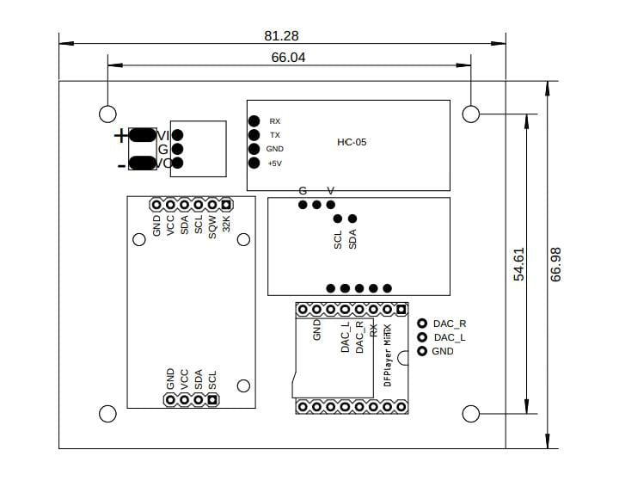

Figure 1. The design of the size of the tool body
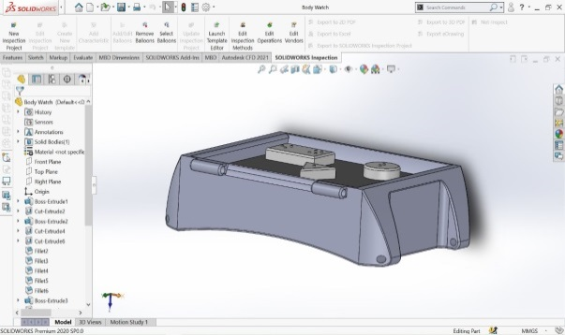

Figure 2. Tool body design process

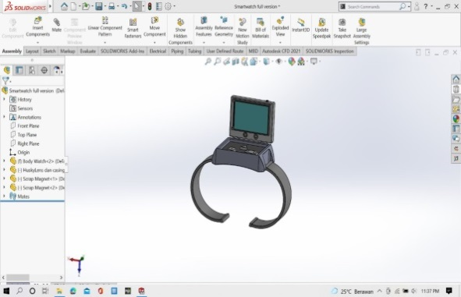

Figure 3. Tool assembly design process
After the design of the tool is designed, it is continued with the design of a series of components on the tool using the Eagle application.

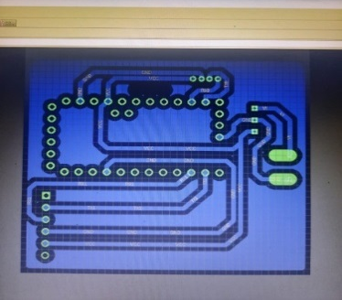

Figure 4. Tool circuit design
After completing the design, the researcher validated the design to technical experts and the visually impaired. The implementation of design validation is carried out based on the validation instrument that has been designed by the researcher. The instrument contains several aspects that will be validated for feasibility. Design validation is carried out to technical experts as experts in determining the feasibility of the tool based on the design results that have been designed. The blind expert validates the feasibility of using the tool for the blind. From the validation results obtained as follows.

Table 1. Result Data Analysis

INDICATOR | BLIND EXPERT |  | TECHNIC  EXPERT
GUESSABILITY
Shape | 4 |  | 4
Content | 4 |  | 4
Tool view | 4 |  | 4
Button layout | 4 |  | 4
Button compatibility | 4 |  | 4
Audio clarity | 4 |  | 4
Simbols compatibility | 4 |  | 4
Picture description compatibility | 4 |  | 4
TOTAL | 32 |  | 32
AVERAGE | 4 |  | 4
LEARNABILITY
Engage users directly | 5 |  | 5
The accuracy of the tool in recognizing images | 4 |  | 4
Image descriptions for the visually impaired are easy to understand | 4 |  | 4
Media in helping educators in learning | 4 |  | 4
Media in helping the visually impaired to access independent information | 4 |  | 4
The application can be used without an internet network | 4 |  | 4
Camera app | 4 |  | 4
Use of accessibility tools for the visually impaired | 4 |  | 4
TOTAL | 33 |  | 33
AVERAGE | 4,125 |  | 4,125
GENERALITATION
Easy-to-use media for the visually impaired |  | 5 |  | 5
The purpose of using the media is easy to understand |  | 5 |  | 5
Media uses safe materials |  | 4 |  | 4
Media makes it easier for educators to apply the use of tools |  | 4 |  | 4
Using easy-to-understand audio |  | 4 |  | 4
TOTAL |  | 23 |  | 23
AVERAGE |  | 4,6 |  | 4,6

Validation test of the value of the ease of understanding the tool with the assessed aspects: shape, appearance, suitability of the tool and the clarity of the tool has an average score for each expert, namely the blind expert 4 and the technical expert 4. Validation test of the value of the ease of use of the tool with the assessed aspects : involvement of the blind, ease of access and ease of application of the tool has an average score for each expert, namely the blind expert 4.12 and the technical expert 4. General validation test on the tool with the assessed aspects: understanding of the blind and ease for others has an average score The average for each expert is 4.6 blind experts and 4.6 technical experts.

- CONCLUSIONS
Based on the results of the Aupender Clock, the application of the tool can be used by blind people in obtaining image information. Where in fulfilling the educational aspect, it can be an alternative for the blind in fulfilling scientific learning. Making tools is designed to meet learning needs and developing vocational skills based on conditions in the field by conducting observations and interviews at the Tuah Sakato PSBN, Padang City. Meanwhile, adult blind people have difficulty in learning and training vocational skills. Vocational learning is also mostly provided in the form of visual information in the form of textbooks, pictures, pamphlets and magazines. Fulfilling the availability of information acquisition needs can be useful for the blind and optimized. The making of the tool is designed by taking into account the needs of the blind based on the results of observations. After designing and making the tool, the tool was tested to determine the success of the tool by testing the tool at the Tuah Sakato PSBN. The results of the trial of the tool are used as evaluation material for repair and refinement of the tool so that it can be published in the community and useful for blind people in meeting learning needs and developing vocational abilities.

REFERENCES
Anna, K. L. 2011. “Katarak Penyebab Utama Kebutaan.” Kompas.
Brady, Erin, Meredith Ringel Morris, Yu Zhong, Samuel White, and Jeffrey P. Bigham. 2013. “Visual Challenges in the Everyday Lives of Blind People.” Conference on Human Factors in Computing Systems - Proceedings (i):2117–26. doi: 10.1145/2470654.2481291.
Giri, A., M., A. Bajari, and E. Maryani. 2019. Book Chapter: Communication & Information Beyond Boundaries.
Hutahaean, Jeprson. 2015. Konsep Sistem Informasi. Sleman: Deepublish.
Karolina, Cut Meutia, Fikom Unpad, Jatinangor Gd, Universitas Padjadjaran, Jl Raya, Bandung Sumedang, Fikom Unpad, Jatinangor Gd, and Universitas Padjadjaran. 2019. “Model Komunikasi Ideal Antara Tuna Netra Dan Visual Reader Dalam Menonton Film Eni Maryani.” 14:61–74. doi: 10.20885/komunikasi.vol14.iss1.art4.
Kemenkes. 2019. “Situasi Disabilitas.” InfoDatin 2442–7659:1–9.
Kurniawan, Iwan. 2015. “IMPLEMENTASI PENDIDIKAN BAGI SISWA TUNANETRA DI SEKOLAH DASAR INKLUSI.” Edukasi Islam Jurnal Pendidikan Islam 04:1044–60.
Meiyani, Neni. 2013. “Penerapan Aliran Filsafat Pragmatisme.” Jassi 12(2):209–20.
Muthmainnah, Rahmita Nurul. 2015. “Pemahaman Siswa Tunanetra (Buta Total Sejak Lahir Dan Sejak Waktu Tertentu) Terhadap Bangun Datar Segitiga.” Jurnal Pendidikan Matematika & Matematika 1(1):15–27.
Organization, Labour International. 2015. “Inklusi Penyandang Disabilitas Di Indonesia.” Descent Work for People With Disabilities 1–4.
Rudiyati, Sari, and Universitas Negeri Yogyakarta. 2010. “Pembelajaran Membaca Dan Menulis Braille Permulaan Pada Anak Tunanetra.” Jassi Anakku 9(1):57–65.
Sutabri, Tata. 2012. Konsep Sistem Informasi. Yogyakarta: Penerbit Andi.
Zeeshan, M. & Aslam, N. 2013. “Resilience and Psychological Wellbeing among Congenitally Blind, Late Blind and Sighted Individuals.” Peak Journals 1(1):1–17.

